ROBOTIC PROCESS AUTOMATION

Prerequisite:

1. Python
2. Python IDE (Recommend Anaconda)
3. Python Library:
   1. RPA
   2. Pandas
   3. Rpaframework (if use robot framework)

Step 1: Installation

1. If you want to use Anaconda, you can ignore Python installation because anaconda installation automatically install Python.
2. Download Anaconda installation here: <https://www.anaconda.com/>
3. D
4. To install Python libraries, open Windows Start > Anaconda3 > Anaconda Prompt (run as administration)
5. After open it, install Pandas and RPA libraries by typing:  
   pip install pandas  
   pip install rpa

Step 2: Setup

1. To open Anaconda, open Windows Start > Anaconda3 > Jupyter Notebook
2. It will be opened through system default browser.
3. To create new file, click New > Python 3  
     
   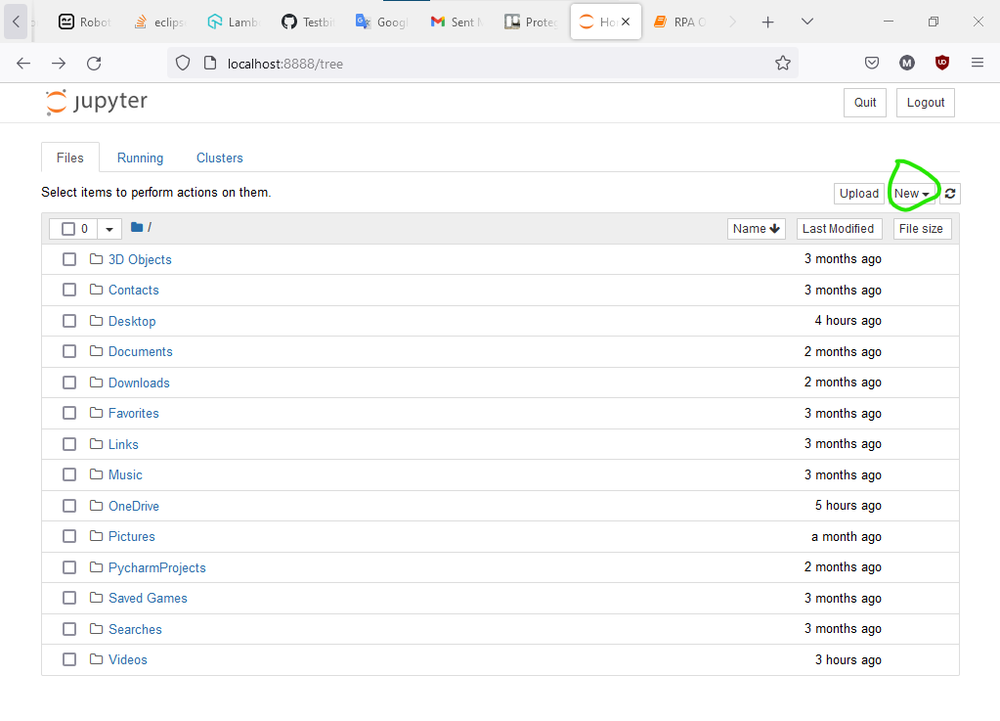

For this tutorial, we try to make appointment in [https://katalon-demo-cura.herokuapp.com/](https://katalon-demo-cura.herokuapp.com/%20) . The process steps are:

1. Open Browser
2. Click Appointment
3. Login: Insert username
4. Login: Insert password
5. Click Login button
6. Choose
7. Click Date icon
8. Choose date
9. Type comment
10. Click Book Appointment

Step 3: Coding

1. Import libraries that we want to use. For this tutorial, RPA and pandas are required. So, type:  
     
   import pandas as p  
   import rpa as r  
   (*we can set any name (for orange word))
2. We start it by setting initial. Type,  
     
   r.init()  
     
   Empty ( ) means we use default parameter.
3. Next, we open the website in browser by typing:  
   r.url(‘URL website)
4. When you want to use RPA operation (such as click, type, etc.), you need to get element paths. To get those, click any element that you want > Right click > Inspect
5. Then, go to word that is highlighted on inspect > Right click > Copy > As Xpath.
6. For click, type:  
   r.click(‘element path’)  
   For type  
   r.type(‘element path’, ‘sampletext)
7. After finish, close the process by typing  
   r.close()

import rpa as r

import pandas as pd  
  
# start the tagUI process

r.init()

# open the website

r.url('https://katalon-demo-cura.herokuapp.com/')

r.wait(3)

# home page

r.click('//*[@id="btn-make-appointment"]')

#r.wait(3)

# login

r.type('//*[@id="txt-username"]','John Doe')

r.type('//*[@id="txt-password"]','ThisIsNotAPassword')

r.click('//*[@id="btn-login"]')

r.wait(3)

# Fill the information

r.click('//*[@id="radio_program_medicaid"]')

r.click('//section[@id="appointment"]/div/div/form/div[4]/div/div/div/span')

r.click('(.//*[normalize-space(text()) and normalize-space(.)="Sa"])[1]/following::td[25]')

r.type('//*[@id="txt_comment"]', 'testing2')

r.click('//*[@id="btn-book-appointment"]')  
  
r.close()